Name: Abdur Rehman Shaikh Roll No.: 55 Class: SY-IT

Experiment 2

Program:

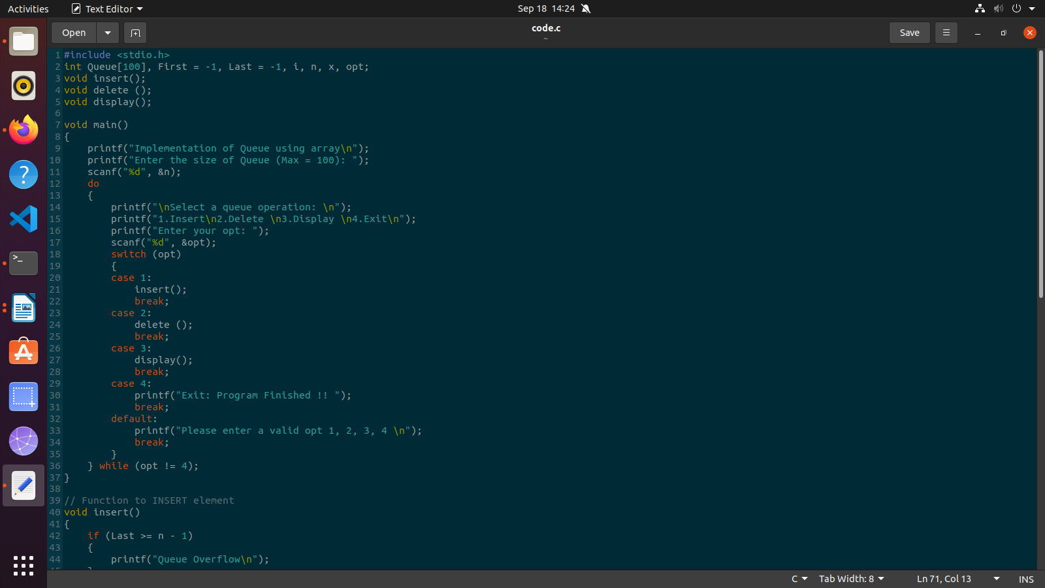

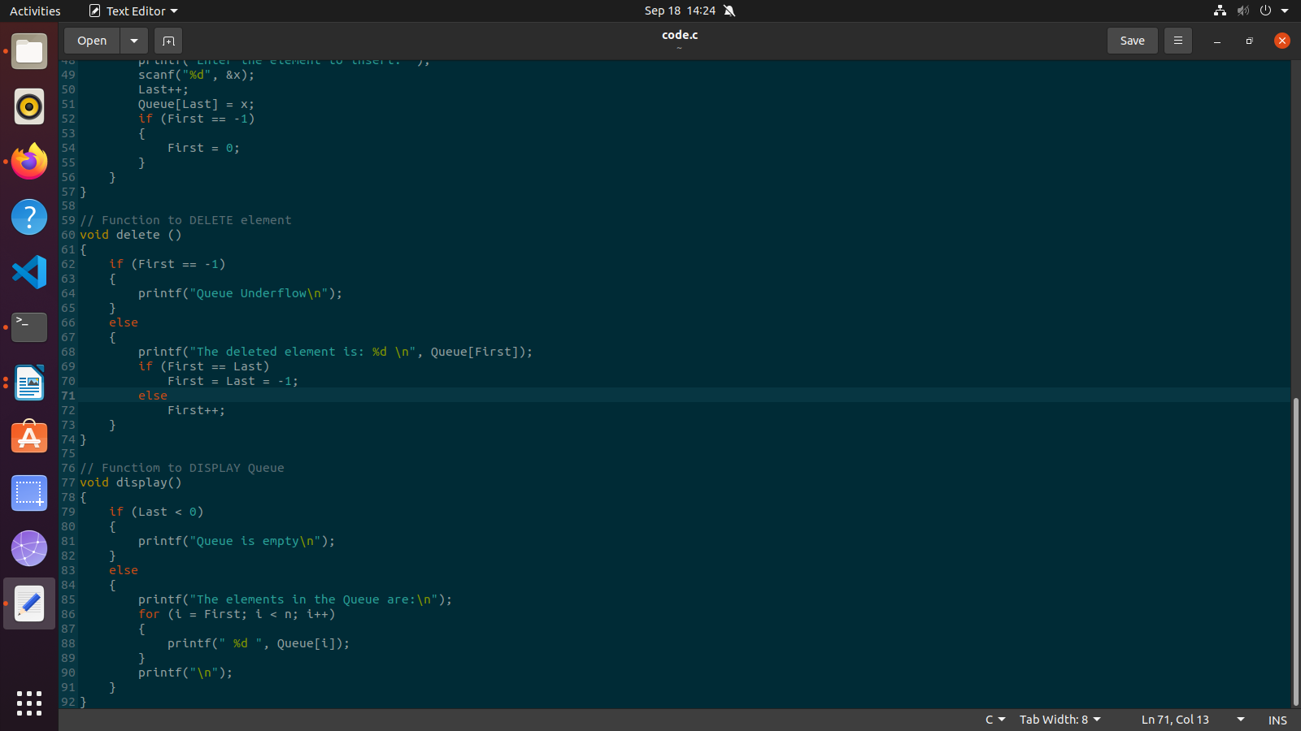

Output:

